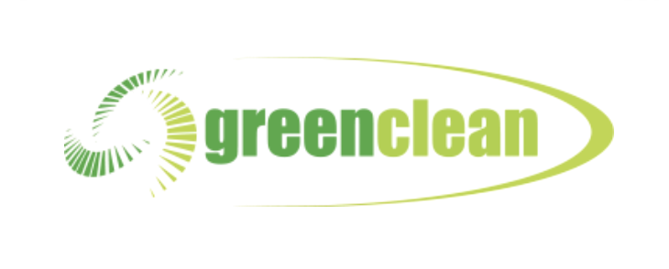

PRIVACY POLICY
Last updated June 12, 2020

Thank you for choosing to be part of our community at Green Clean (“Company”, “we”, “us”, or “our”). We are committed to protecting your personal information and your right to privacy. If you have any questions or concerns about our policy, or our practices with regards to your personal information, please contact us at hello@greencleanuk.co.uk.
When you visit our website https://greencleanuk.co.uk/, and use our services, you trust us with your personal information. We take your privacy very seriously. In this privacy policy, we seek to explain to you in the clearest way possible what information we collect, how we use it and what rights you have in relation to it. We hope you take some time to read through it carefully, as it is important. If there are any terms in this privacy policy that you do not agree with, please discontinue use of our Sites and our services.
This privacy policy applies to all information collected through our website (such as https://greencleanuk.co.uk/), and/or any related services, sales, marketing or events (we refer to them collectively in this privacy policy as the "Services").
Please read this privacy policy carefully as it will help you make informed decisions about sharing your personal information with us.

WHAT INFORMATION DO WE COLLECT?

Personal information you disclose to us
In Short: We collect personal information that you provide to us.
We collect personal information that you voluntarily provide to us when expressing an interest in obtaining information about us or our products and services, when participating in activities on the Services or otherwise contacting us.
The personal information that we collect depends on the context of your interactions with us and the Services, the choices you make and the products and features you use. The personal information we collect can include the following:
Publicly Available Personal Information. We collect email addresses; phone numbers; first and last name; and other similar data.
All personal information that you provide to us must be true, complete and accurate, and you must notify us of any changes to such personal information.

WILL YOUR INFORMATION BE SHARED WITH ANYONE?
In Short: We only share information with your consent, to comply with laws, to provide you with services, to protect your rights, or to fulfill business obligations.
We may process or share data based on the following legal basis:
- Consent: We may process your data if you have given us specific consent to use your personal information in a specific purpose.
- Legitimate Interests: We may process your data when it is reasonably necessary to achieve our legitimate business interests.
- Performance of a Contract: Where we have entered into a contract with you, we may process your personal information to fulfill the terms of our contract.
- Legal Obligations: We may disclose your information where we are legally required to do so in order to comply with applicable law, governmental requests, a judicial proceeding, court order, or legal process, such as in response to a court order or a subpoena (including in response to public authorities to meet national security or law enforcement requirements).
- Vital Interests: We may disclose your information where we believe it is necessary to investigate, prevent, or take action regarding potential violations of our policies, suspected fraud, situations involving potential threats to the safety of any person and illegal activities, or as evidence in litigation in which we are involved.
More specifically, we may need to process your data or share your personal information in the following situations:
- Vendors, Consultants and Other Third-Party Service Providers. We may share your data with third party vendors, service providers, contractors or agents who perform services for us or on our behalf and require access to such information to do that work. Examples include: payment processing, data analysis, email delivery, hosting services, customer service and marketing efforts. We may allow selected third parties to use tracking technology on the Services, which will enable them to collect data about how you interact with the Services over time. This information may be used to, among other things, analyze and track data, determine the popularity of certain content and better understand online activity. Unless described in this Policy, we do not share, sell, rent or trade any of your information with third parties for their promotional purposes.
- Business Transfers. We may share or transfer your information in connection with, or during negotiations of, any merger, sale of company assets, financing, or acquisition of all or a portion of our business to another company.
- Third-Party Advertisers. We may use third-party advertising companies to serve ads when you visit the Services. These companies may use information about your visits to our Website(s) and other websites that are contained in web cookies and other tracking technologies in order to provide advertisements about goods and services of interest to you.
- Business Partners. We may share your information with our business partners to offer you certain products, services or promotions.

DO WE USE COOKIES AND OTHER TRACKING TECHNOLOGIES?
In Short: We may use cookies and other tracking technologies to collect and store your information.
We may use cookies and similar tracking technologies (like web beacons and pixels) to access or store information. Specific information about how we use such technologies and how you can refuse certain cookies is set out in our Cookie Policy.

HOW LONG DO WE KEEP YOUR INFORMATION?
In Short: We keep your information for as long as necessary to fulfill the purposes outlined in this privacy policy unless otherwise required by law.
We will only keep your personal information for as long as it is necessary for the purposes set out in this privacy policy, unless a longer retention period is required or permitted by law (such as tax, accounting or other legal requirements). No purpose in this policy will require us keeping your personal information for longer than 1 year.
When we have no ongoing legitimate business need to process your personal information, we will either delete or anonymize it, or, if this is not possible (for example, because your personal information has been stored in backup archives), then we will securely store your personal information and isolate it from any further processing until deletion is possible.

HOW DO WE KEEP YOUR INFORMATION SAFE?
In Short: We aim to protect your personal information through a system of organizational and technical security measures.
We have implemented appropriate technical and organizational security measures designed to protect the security of any personal information we process. However, please also remember that we cannot guarantee that the internet itself is 100% secure. Although we will do our best to protect your personal information, transmission of personal information to and from our Services is at your own risk. You should only access the services within a secure environment.

WHAT ARE YOUR PRIVACY RIGHTS?
In Short: You may review, change, or terminate your account at any time.
If you are resident in the European Economic Area and you believe we are unlawfully processing your personal information, you also have the right to complain to your local data protection supervisory authority. You can find their contact details here: http://ec.europa.eu/justice/data-protection/bodies/authorities/index_en.htm.
Cookies and similar technologies: Most Web browsers are set to accept cookies by default. If you prefer, you can usually choose to set your browser to remove cookies and to reject cookies. If you choose to remove cookies or reject cookies, this could affect certain features or services of our Services. To opt-out of interest-based advertising by advertisers on our Services visit http://www.aboutads.info/choices/.

DO WE MAKE UPDATES TO THIS POLICY?
In Short: Yes, we will update this policy as necessary to stay compliant with relevant laws.
We may update this privacy policy from time to time. The updated version will be indicated by an updated “Revised” date and the updated version will be effective as soon as it is accessible. If we make material changes to this privacy policy, we may notify you either by prominently posting a notice of such changes or by directly sending you a notification. We encourage you to review this privacy policy frequently to be informed of how we are protecting your information.

HOW CAN YOU CONTACT US ABOUT THIS POLICY?
If you have questions or comments about this policy, you may email us at hello@greencleanuk.co.uk.

